Part 1.
[d] | [id]/[əd] | [t]
banned | waded | napped
bowed | lifted | tricked
freed | pounded | puffed
behaved | misted | maxed

[id] /[əd] occurs after alveolar stop segments.
[t] occurs after a voiceless and non alveolar stop segements.
[d] occurs after a voiced and non alveolar stop segements.

Part 2.
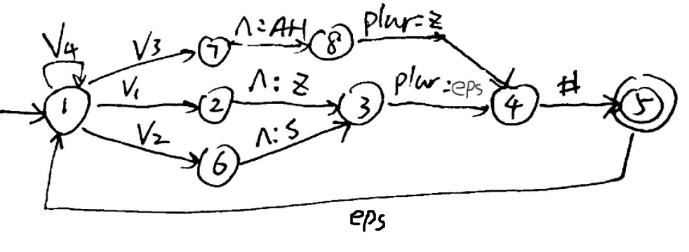
V1=all voiced nonsibilant sounds = {aa, ae, aw, ay, b, d, dh, ih, iy, m, n, uw, v, w, g, v, nx, ng, l, r, oy, ey, eh, uh, ao,ah,ow, nx,ng,er}
V3=all sibilant sounds ={s,z,sh,zh,ch,jh}
V4=ɛ-{‘^’,plur,eps}
V2=all unvoiced and nonsibilant =V4-V1-V3

